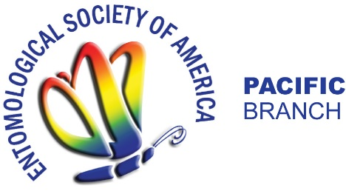

PBESA Student Travel Award Application Form

Application Form and supporting materials should be submitted by the graduate/undergraduate student through the Awards page on the Pacific Branch ESA web site, http://entsoc.org/pacific-branch-awards
(PDF only) by February 8, 2017. Please note that you will need a BRIEF letter of support from your advisor or other mentor. Please compile all application materials in one PDF document. Any questions can be directed to the PBESA Student Travel Awards Chair, Dr. Michael Bush (bushm@wsu.edu).

Applicant Information
- Name:
- Contact information (mailing address, phone number, email address):

- Address and full name of the institution of graduate/undergraduate studies:

- Degree program
Undergraduate; Master’s degree; Doctoral degree

- Beginning date of the student’s current degree program:
- Anticipated date of graduation:
- Current GPA:

- Title of presentation planned for Pacific Branch ESA meeting:

- Type of presentation (check one):
Oral Presentation; Poster Presentation

- Presentation session:
Student Competition Invited Speaker in Symposium General Session

- Indicate if you are/will be receiving additional financial support. Please indicate the amount and or items covered by these sources.
Your Department/University. Amt. $__________
An Advisor/Major Professor. Amt. $__________
Other funding sources (Please list). Amt. $_________
___________________________________________
___________________________________________
___________________________________________

- Abstract of presentation (250 words or less).

- A brief description (1 paragraph) of the student’s current research activities:
- Include BRIEF letter of support from supporting faculty member (300 words or less).

